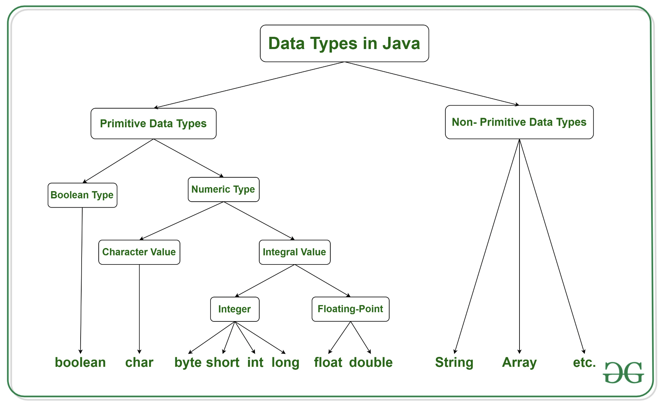

2^n -> 2^8 = 256 /2 = 128 -128 to 127
Type | Description | Default | Size | Example Literals | Range of values
boolean | true or false | FALSE | 1 bit | true, false | true, false(1,0)
byte | two's-complement integer | 0 | 8 bits | (none) | -128 to 127
char | Unicode character | \u0000 | 16 bits | ‘a’, ‘\u0041’, ‘\101’, ‘\\’, ‘\’, ‘\n’, ‘β’ | characters representation of ASCII values  0 to 255
short | two's-complement integer | 0 | 16 bits | (none) | -32,768 to 32,767
int | two's-complement intger | 0 | 32 bits | -2,-1,0,1,2 | -2,147,483,648  to  2,147,483,647
long | twos-complement integer | 0 | 64 bits | -2L,-1L,0L,1L,2L | -9,223,372,036,854,775,808  to  9,223,372,036,854,775,807
float | IEEE 754 floating point | 0 | 32 bits | 1.23e100f , -1.23e-100f , .3f ,3.14F | upto 7 decimal digits
double | IEEE 754 floating point | 0 | 64 bits | 1.23456e300d , -123456e-300d , 1e1d | upto 16 decimal digits

What are Primitive Types in Java?
- Primitive types are the basic building blocks of Java.
- They are not objects.
- Their values are stored directly in stack memory.

int x = 10;
int y = x;
y = 20;
System.out.println(x); // Output: 10
✅ x and y are independent. Changing y does not affect x.

What are Reference Types?
- Reference types include everything other than primitives: arrays, classes, interfaces, etc.
- Variables of these types store a reference (memory address) to the object in heap memory.

📌 Common Reference Types:
- Classes (e.g., String, Scanner, ArrayList)
- Arrays
- Custom objects
- Interfaces

Keywords in Java:
In Java, keywords are predefined, reserved words that have a special meaning to the compiler. They cannot be used as identifiers (such as variable names, function names, or class names).

🔑 List of Java Keywords:
Keyword | Purpose
abstract | Defines an abstract class or method (incomplete and needs to be implemented by subclasses).
assert | Used for debugging purposes to validate assumptions.
boolean | Defines a variable of type boolean (true/false).
break | Exits from a loop or switch statement.
byte | Defines a variable that can store an 8-bit integer.
case | Defines a branch in a switch statement.
catch | Catches exceptions in a try-catch block.
char | Defines a variable that can store a single 16-bit Unicode character.
class | Defines a class.
const | Reserved but not used in Java (historical).
continue | Skips the current iteration of a loop and continues with the next iteration.
default | Specifies the default case in a switch statement.
do | Defines the start of a do-while loop.
double | Defines a variable that can store a 64-bit floating-point number.
else | Defines the alternative block of code in an if-else statement.
enum | Defines a set of constant values (enumerated type).
extends | Indicates inheritance, allows a class to inherit methods and fields from a superclass.
final | Defines a constant or prevents modification of a variable, method, or class.
finally | Defines a block of code that will execute after a try-catch, whether an exception was thrown or not.
float | Defines a variable that can store a 32-bit floating-point number.
for | Defines the start of a for loop.
goto | Reserved but not used in Java (historical).
if | Defines the condition in an if statement.
implements | Indicates that a class implements an interface.
import | Imports other classes or entire packages.
instanceof | Checks if an object is an instance of a specified class or subclass.
int | Defines a variable that can store a 32-bit integer.
interface | Defines an interface (a contract of methods).
long | Defines a variable that can store a 64-bit integer.
native | Specifies that a method is implemented in native code (outside of Java).
new | Creates new objects or arrays.
null | Represents the null reference (points to no object).
package | Defines a package to group related classes and interfaces.
private | Specifies that a member is accessible only within its own class.
protected | Specifies that a member is accessible within its own package and by subclasses.
public | Specifies that a member is accessible from anywhere.
return | Exits from a method and optionally returns a value.
short | Defines a variable that can store a 16-bit integer.
static | Defines a class-level method or field, shared by all instances of the class.
strictfp | Ensures that floating-point calculations adhere strictly to the IEEE 754 standard.
super | Refers to the superclass (parent) class or calls its constructor or method.
switch | Defines a switch statement to choose between multiple options.
synchronized | Ensures that a method or block of code is accessed by only one thread at a time.
this | Refers to the current object instance.
throw | Used to throw an exception manually.
throws | Declares exceptions that a method may throw.
transient | Prevents a field from being serialized (saved when the object is saved).
try | Defines the start of a block of code to try catching exceptions.
void | Specifies that a method does not return a value.
volatile | Ensures that a field’s value is always read from and written to the main memory.
while | Defines the start of a while loop.

🔍 Key Points:
- Reserved: These words are reserved for Java’s syntax and cannot be used as names for variables, methods, classes, etc.
- No functionality for some: For example, const and goto are reserved but not used in Java.

✅ Commonly Used Keywords:
- class, public, private, static, final, int, for, if, return, try, catch, throw, throws

